# Actvity 1:

myList=[]

for i in range(5):

val=input("enter a value:")

myList.append(val)

print("the given list is")

print(myList)

Result:

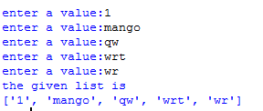

# Activity 2:

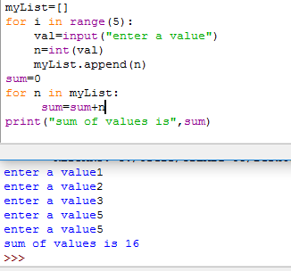

# Activity 3:

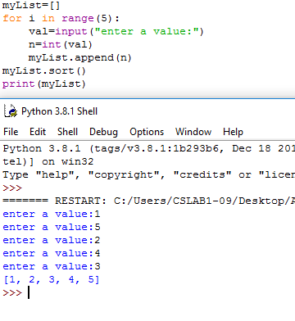

# Activity 4:

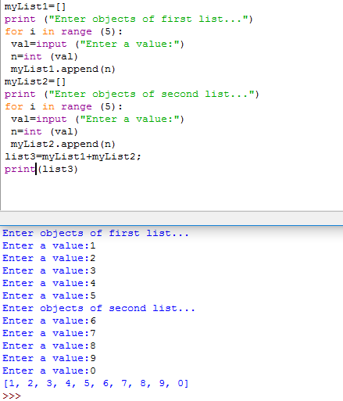

# Activity 5:

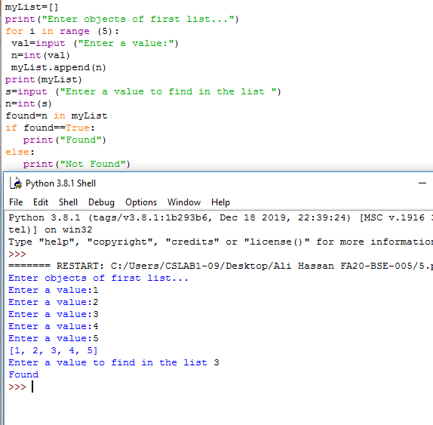

# Activity 6:

# 

# Activity 7

